Mrs. Berger Wants YOU to take a Learning Preference Inventory!

What is a Learning Preference Inventory?

Learning preference inventory, styles test, modality inventory, intelligence test-they all mean the same thing! Each test is made up of several questions, similar to a survey, designed to help determine how YOU learn best. Each intelligence is unique, but no one intelligence is better than another. Each person has many different learning styles, but most often, one stands out more than another.

What does this mean for YOU?

After taking a learning preference inventory, you will know how you learn best and what style(s) make learning a little more difficult. This is very important!
Once you know how you best learn, you can use strategies from that specific style to help in homework or studying for tests. You can become a better student because you know on what to focus and what is more difficult for you. This means you can spend more time in an area that does not possess your strength in order to become a better student!

Why is it important to Mrs. Berger?
“We all learn in many ways, but some of us learn much better in some ways (note packet).”
Once I know how you best learn, I can teach in a variety of ways that call on many types of intelligence. From day to day, I can change the way I teach to better suit different types of learning, or I can teach in a way that reaches more than one intelligence at a time! I could use a PowerPoint that contains words for the linguistic learners, charts for the visual/spatial learners, and describe things using motions and movement for the kinesthetic learners.

Directions:
Directions

Take 2 Surveys!
I have listed below two learning style inventories. In order to get the most accurate interpretation of how you learn, you will need to take both surveys. You can either click on the link provided or type each in an internet browser.
The first survey consists of 8 different intelligences, after Howard Gardner’s Theory of Multiple Intelligences. There are 24 questions. It will show you your results based on the 8 different principle intelligences. Record your highest and lowest percentages. If you have many that are very close, record those results and each of the styles that have fairly close numbers. Sometimes you can be fairly balanced, or multi-modo, in learning styles.
http://www.edutopia.org/multiple-intelligences-assessment
After taking this survey, you can learn more about what each of the intelligences mean by going to the following link: http://enhancinged.wgbh.org/research/multi/examples.html
The second learning inventory has 3 possible styles as results: visual, auditory, or tactile. At the bottom of the webpage, it explains what each of the 3 mean. Make sure you read about them before you submit your results, because the guide will go away once you have submitted. The survey consists of 24 questions. Record the result the site generates. You will only get one answer.
http://www.personal.psu.edu/bxb11/LSI/LSI.htm#ShowResults
By seeing the results from both, I hope to see what style best suits you to help you succeed in the classroom.

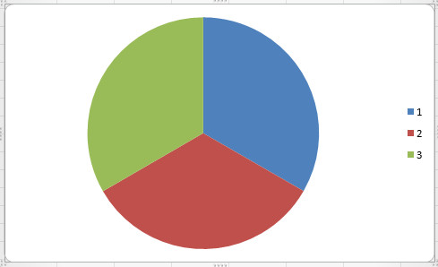
Tips to Help You Learn
Tips to Help You Learn

Tactile Learners:
-Move around while memorizing
-Stand while doing homework
-Create gestures for vocabulary
-Use musical rhythms for memorizing patterns
-Create your own works to master new material

Auditory Learners:
-Face the speaker
-Watch videos or podcasts
-Repeat facts out loud
-Create songs to help you remember what you learn
-Use word association to help remember facts

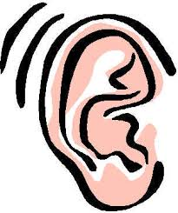
Visual Learners:
Highlight important information
Study from the computer
Make study cards with pictures
Draw pictures as you learn
Watch a video about what you’re learning
Make to-do lists

To read more about what these styles mean for you, go to: http://school.familyeducation.com/intelligence/teaching-methods/38519.html
References
Farwell, T. (2012). Visual, Auditory, Kinesthetic Learners. (P. Education, Producer) Retrieved 2015, from Family Education: http://school.familyeducation.com/intelligence/teaching-methods/38519.html
Learning Styles Tips for Kids. (n.d.). Teachers Pay Teachers. Retrieved February 9, 2014, from http://www.teacherspayteachers.com/Product/Learning-Styles-Tips-for-Kids- 157079
Multiple Intelligences: Definitions and Examples. (2002). (Corporation for Public Broadcasting) Retrieved from Enhancing Education: http://enhancinged.wgbh.org/research/multi/examples.html

