Classroom Management Philosophy

Juliana Berger
Dr. Carmelita Lamb
Final Fall 2015

I would like to start out my classroom management philosophy with a brief introduction and story. I work as the Assistant Director of Religious Education at Saint Anne Elementary School here in Bismarck. For the past three years, I have been volunteering at Saint Anne’s as a Parish Religious Education Program (PREP) teacher for 7th graders from the surrounding public schools in the Bismarck/Mandan districts. Saint Anne School is in between 13th and 14th Streets North, relatively closed to the capital and the Medicine Shoppe in Bismarck. To say the least, the students that attend the PREP are very diverse socioeconomically. I have always been aware of this, but since I have been moved up to a paid position in the program, I see all the students who come through the school, ranging from 1st grade all the way through 8th grade. Aside from noticing that some students had appropriate clothing as it has gotten colder and others had not, I began hearing about the lives of some of the students. The Director of Religious Education would inform me about what she thought necessary for me to hear, and one story really struck me.
After 4 weeks of the program being up and running, meaning we had already had 4 classes this year, the Director explained to me that my brother and I (we teach together) would be having a new student join our class that night. I told her that was great, but asked why he had not been enrolled earlier. Had he not been in the program before? I was sure I recognized the name. She said he had, but his family had recently fallen into many issues. His dad, about a year and a half earlier, was arrested for physically abusing his mom, which was not the first time the abuse had ever happened. During that process, his mom decided to divorce her alcoholic husband, although he was 8 months sober and wanted to work things out. She refused because a month after he was arrested, she had begun dating a new man, who, by the way, had also been in jail, but for other reasons. The mom had told the children that he was only a friend, but both the boy in my class and his older brother knew better than that. Then, most recently, his mom was fired from her job. It hit me like a boulder. I asked the Director, “How many people do you think know about this boy’s circumstances?” She said, “I would assume you, me, and some family. She (the boy’s mom) said that his other teachers do not really know.”
This story pulls on the heart strings for most teachers in the profession. When I heard the story, I began think about this boy a lot. And then, as I reflected further, it made me wonder, “How many of my other students in the past 3 years have gone through similar or worse situations to this?” In my classroom, every student will know that he or she has value and is loved. My classroom management philosophy will reflect this statement definitively, clearly indicating ways in which each student will have a sense of value and know that there is at least one person in this world working for him/her. The task is large, and it will not be easy, but with this in mind, I believe anything is possible.
A large part of my classroom management philosophy will also highlight my general philosophy on teaching, touching on the points of taking responsibility for student learning, demonstrating strong pedagogical content knowledge, and displaying professional characteristics. Each of these three concepts will be threaded in my classroom management philosophy.
First and foremost, my classroom management philosophy will reflect the statement that every student who enters my classroom will feel valued and loved. Based on this, my classroom management philosophy begins with a principle’s approach to management (Fay and Funk, 1995). This is the umbrella to the rest of my philosophy. Under the principle’s approach, there are a few rules in my classroom, all of which are general and allow for freedom of both the student and myself. By this I mean that I have the flexibility to implement the rules consistently but possibly not in the same way, and the students have the right of a voice in the classroom (Fay and Funk, 1995). Under the values approach, I will implement both rules and procedures. Integrated within these two concepts of my principles approach will be the four principles of a Love and Logic classroom: (1) Maintain the dignity of students and teachers at all times; (2) When possible, share control; (3) When possible, share thinking; and finally (3) When possible, use empathy/consequences to guide student behavior and self-concept (Fay and Funk, 1995). These are the four main guiding principles that will be used my classroom, which will be assimilated into the rules and procedures employed in my classroom. The rules will be developed with the help of the students, establishing them within the first 2 classes we have together. This is a critical aspect of classroom management, because when students personalize with management methods, they are more likely to listen and internalize their behavior (Marzano, 2003). Procedures are also a key component in being in charge of my classroom. In secondary history education, transitions do not occur often during periods, but when they do occur, they must be smooth so little time is wasted. To make this happen, I will always have a clear agenda and signals for transitions so both the students and myself are aware of the change.
My classroom management philosophy also requires close and consistent contact with parents. I believe that it is important that this is at the top of my list, only second to basing the structure off the values approach, because parental involvement is a leading contributor in student success. Also, behaviors at home are mimicked in schools, and some parents often even see schools as a supplement for their discipline. It is our job to see that the education of proper behavior is beginning in the home. Keeping my door open and also always allowing parents to have a voice is one way in which I will try to keep parents involved. I will also have a classroom webpage, and I will keep parents updated on their individual students.
In my classroom, I can name a few procedures that I will definitely implement at this point. I have practiced some of these on my students for PREP, which is a great laboratory for my classroom management strategies. My first routine is for entering the classroom. As students enter, they will be greeted at the door by myself. As they sit down, there will be some sort of bellwork activity on the board (Wong and Wong, 2009). It will range from a review of the previous day, a topic of history we will not be able to cover in class (possibly related to “This Day in History”), to something not related to the subject, like a creative journal activity or telling me something about the previous evening. This will be taught, rehearsed, and reinforced when necessary (Wong and Wong, 2009). One specific bellwork activity that I came up with will occur every Monday, and I call it “Ordinary Moments in EXTRAORDINARY Lives.” I will explain this to my students during the first class we have together. My purpose in this activity is that students will tell me about their weekend or something that is going on in their lives that is important to them as individuals. I realize that poverty is real in some families, and by asking the students outright who did something fun that weekend does not pose a fair question. I want them to write anything they want and know that it is important to me. Something ordinary.
After bellwork, the morning routine continues as I will begin class with three claps saying “1-2-3” as the students will respond back with the same. After getting their attention, I will ask for a fist-to-five on how they are doing that day. This gives me a general idea of how each student is doing without really drawing a lot of attention to the individual. If they want to share why they feel the way they do, they can, but no one is required to share. This, too, will be taught, rehearsed, and reinforced.
I will focus my classroom management philosophy highly off the Love and Logic approach that we discussed in class. In dealing with difficult or angry students, reacting to unacceptable behavior, giving options, the way I speak, and my constant effort to help students become self-efficacious and develop their own self-concept the principles and Love and Logic approaches will be seen throughout my entire philosophy. Let’s go further by doing authentic examination of what this will look like in my classroom.
A principles approach in general looks like having a few rules that are consistently based on values but not always followed in the same way. The values from which my rules will be based are: (1) Dignity and respect for all persons will be maintained; (2) Every student has a voice; (3) Students and teacher hold each other accountable; (4) Unacceptable behavior will have a consequence. I will have these posted on a large sheet of paper in the classroom labeled, “Mrs. Berger’s Promises.” Then, the students, with my prompting, will agree on 3 rules that will govern our classroom. The more the students are involved in the behavior guidelines, the more likely it is that they will follow them, and even yet, be more aware when one is broken and are more likely to internalize the behavior as their own. If a consequence is necessary, it could be given in different ways, depending on the student, situation, and circumstances. In situations where consequences are eminent, I also will recognize the option of waiting to distribute the consequence. This allows the student and myself to look back at the situation after it has passed and, hopefully, cool off. Especially for the student, I believe this is important for him/her to be thinking about it, internalizing the behavior, and hopefully recognizing why the behavior was unacceptable (Fay and Funk, 1995). In my classroom, I would wait until the end of the period to discuss the situation. If the student is still bothered and heated, I would say that he/she can come back and visit with me between that point and the end of the day. If the student had not calmed down, we could discuss it into the next day, when the student will have had plenty of time to think about the situation and internalize the behavior (Fay and Funk, 199545). One thing I also like to do when I teach PREP is give a student who is being disruptive an opportunity to help me at the board or hand out worksheets. Writing on the board is sometimes just what they need to get back on track. Most of the time, they are bored because they do not understand the material or the subject is too easy. Giving them this opportunity often supplements for that boredom. If it continues, though, I will of course, try to deal with any situation in the classroom as it has happened, giving the student choices for ending the behavior, saying, for example, “You can either see me after class or give me the pencil.” (Fay and Funk, 1995).
All of this is great. Student involvement is necessary in constructing a well-managed classroom management plan. After this, then what? As part of my teaching philosophy, it is important that I take responsibility for student learning, which involves student engagement. The more engaging the lessons or activity, the less likely a student or group is to act out. To do this, I will develop plans that focus on targeting students’ emotions, interest, showing them why it is important, and showing them its usefulness and worth placed in their quality world (Marzano and Pickering, 2011). This also comes in the form of having engaging and meaningful bulletin boards and available activities throughout the classroom. On the final pages, you can see examples of bulletin boards and other engaging classroom activities to keep students engaged and focused. With these, emotions and critical thinking skills will be enhanced and targeted.

Slide: Sample Bellwork daily assignment.
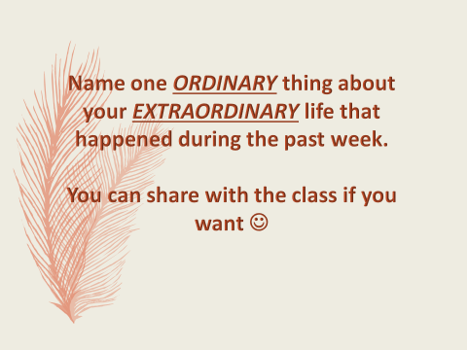
Paper Heading Example: Will be typed and taped to desks.

Sample paper heading. Will be typed and taped to the corner of each desk.

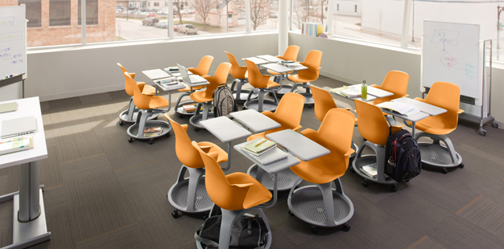

Desk arrangement: Light of Christ has node desks. They are easy to move, but I like this arrangement best because I can more easily generate group work and discussions. It would also be helpful for test review games and debates. If I were to have a classroom with table desks, I would apply a similar setup.

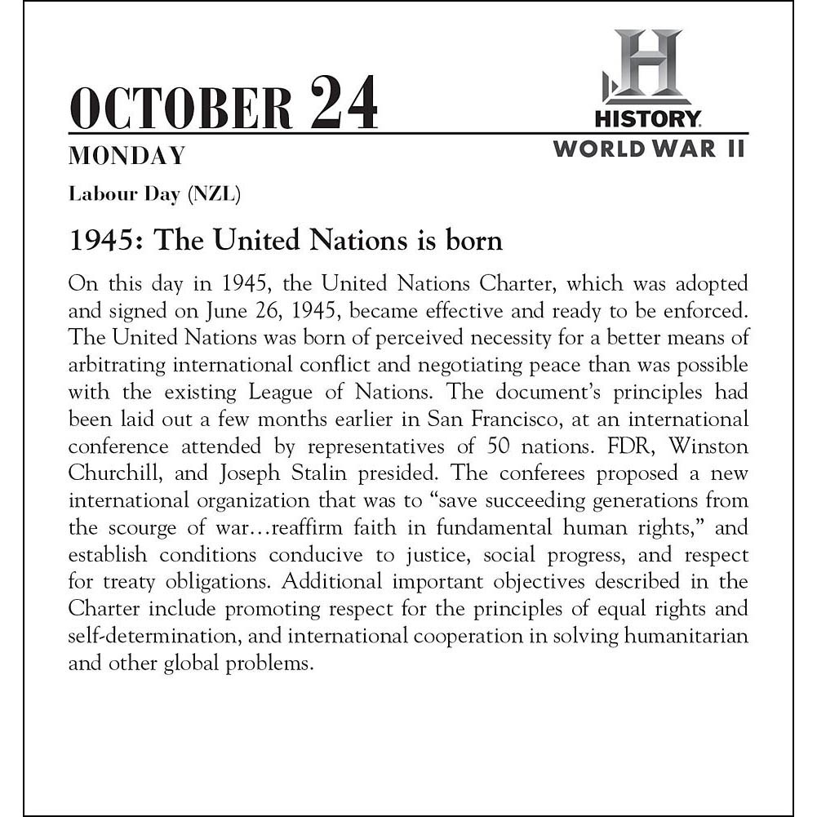
Argument/Thesis
Research
Interests
Question
Answer
Let’s Have an Argument!
“Let’s Have an Argument” Bulletin Board:
Sounds like something that should interest the young adolescent mind while addressing an important task in writing in history from the very first day.
“This Day in History” Calendar/Bulletin Board:
This is an example of an event for my bulletin board. I would add events such as this to a more colorfully and fun-looking calendar for my students to view at their leisure. It sparks additional interest in history besides what we are learning in class.

Period C

Period B
Period A

Absent Student Work

Absent Student Work

This is my procedure for absent student work, turning in homework, and picking up homework. I will have two sets of these folders, one labeled “Turn In” and the other labeled “Pick Up.” This should provide ease when students are sick or absent because I will have all the work in the “Absent Student Work” folder. Turning in assignments and picking them up will be the responsibility of the student, with a kind reminder from me. If there is work left in the “Pick Up” folders at the end of the week, I will keep it in my records until the end of the quarter.

References:
Fay, J. & Funk, D. (1995). Teaching with Love & Logic: Taking control of the classroom. Love & Logic Press Inc: Golden, CO.
Marzano, R. J. (2003). Classroom Management that Works: Research Based Strategies for Every Teacher. ASCD: Alexandria, VA.

Marzano, R. J. & Pickering, D. J., with Heflebower, T. (2011). The Highly Engaged Classroom. Marzano Research Laboratory: Bloomington, IN.

Wong, H. K. & Wong, R. T. (2009). Classroom Management. Harry Wong Publications: Mountain View, CA.

